VIDIVOX

Design Decisions

User Manual

SOFTENG 206

Hannah Sampson

Software Engineering Design

Table of Contents

1 Introduction 4

2 GUI Design 5

2.1 Choice of programming language and packages used 5

2.1.1 Discussion on Use of Java in Project 5

2.1.2 Other Libraries 5

2.2 Colour Consideration 5

2.3 Discussion of Layout 5

2.3.1 Layout of Panels 5

2.3.2 Layout of Buttons and Text within Each Panel 5

2.4 Presentation of Information 5

2.4.1 Pop-up Messages 5

2.4.2 Text Messages 5

2.5 Main Frame 5

2.6 Adding Audio 5

2.7 Create a New Audio 5

3 Discussion about functionality of product 6

3.1 Creating Commentary Audio Files 6

3.2 Playing a Video 6

3.3 Adding Audio Files to a Selected Video 6

3.4 Saving Videos 6

3.5 Festival Functionality 6

3.1 What was the motivation of the selected functionality? 6

3.2 What were the usability decisions? 6

4 Discussion about code design and development of product 7

4.1 Documentation of software design 7

4.2 Development Process 7

4.2.1 Development Process Implemented 7

4.2.2 How this Affected the Project 7

4.2.3 Discussion on Process 7

4.3 Innovative Implementation 7

4.4 Shortcut keys- motivations, implementation 7

4.5 Other developmental issues. 7

5 Description of Evaluation and Testing 8

5.1 Evaluation and Testing: Developer 8

5.2 Evaluation from Clients after Pair Project 8

5.2.1 Changes from Assignment 3 8

5.2.2 Justification for decisions 8

5.3 Results of Evaluation and Testing of product by allocated Class Peers 8

5.3.1 Changes from Beta version 8

5.3.2 Justification for decisions 8

5.4 Final Design Testing 8

5.4.1 Error handling 8

5.4.2 Bugs and Fixes 8

6 Future Work 9

7 Conclusions 10

8 Appendices 11

8.1 User Manual 11

# 1 Introduction

There are a number of different video editors and each has its own range of functionality aimed at specific target audiences. Our project was aimed around the idea of being able to create a documentary-type video, where the video plays and keeps its own original soundtrack but a voice is added over the top, describing the video. This meant a lot of emphasis was put on creating appropriate audio commentaries, and being able to dictate where each of these audio files fits into the video.

Our work has involved developing a tool that lets the user take a standard video file and add different audio files to it, whether these audios are music files of commentaries that the user creates. We worked primarily in Java, with a Java specific video manipulation tool: vlcj. By working in Linux, we could also implement Linux system calls to process the media files, as well as working in speech synthesis with festival to create audio files from text.

There are a number of different video editors available, all aimed at a different level of user. VIDIVOX is aimed at a home user, and hence is required to have obvious functionality, and easy use. All of the design decisions throughout this work has taken into account how this kind of user would feel using the product.

All design and implementation decisions had to work towards creating “an easy to use” Video Commentator, which would be easy for a non-technical person to use. The main points are:

* A well designed graphical user interface
* Help on how to use the different features of the tool
* File retrieving abilities
* The ability to create, play back, overlay and save multi-media material

In the discussion section of the report, I have detailed the design decisions made at each stage of development, why these decisions were made, any features of the product and how the GUI interacts with the user, e.g. error handling, system feedback.

The development is broken up into seven sections:

* GUI Design
* Functionality
* Code Design
* Evaluation and Testing
* Future Work
* Conclusions

Each of these subheadings is broken up into sections based on the stages at which feedback from the client and other users was received as this signalled obvious breaks and re-evaluation of design implementation in the project.

This report also includes a user manual, which includes documentation and help with all available functionality.

# 2 GUI Design

## 2.1 Choice of programming language and packages used

### 2.1.1 Discussion on Use of Java in Project

### 2.1.2 Other Libraries

## 2.2 Colour Consideration

My video player was aimed at a non-technical user, but still an adult. This meant that I didn’t want to use big bright colours and text as this would make the application look childish and put users off. Instead I wanted the buttons and general layout to be easy to read and view, but not overpowering or taking attention away from the video that was playing. Hence to keep everything easy to read I went with black text on a light grey frame (not white as if it is too bright this could easily cause eye fatigue), with a small to medium text to make sure users know that it is aimed at adults.

## 2.3 Discussion of Layout

### 2.3.1 Layout of Panels

### 2.3.2 Layout of Buttons and Text within Each Panel

## 2.4 Presentation of Information

### 2.4.1 Pop-up Messages

#### 2.4.1.1 Error Messages

There is only one error message that is displayed to the user when the application is running. This is when the video player tries to play a chosen video and fails.

#### 2.4.1.2 Information Messages

Information messages are mainly presented when the user has selected for something to happen in the background

#### 2.4.1.3 General Messages

### 2.4.2 Text Messages

## 2.5 Main Frame

## 2.6 Adding Audio

## 2.7 Create a New Audio

# 3 Discussion about functionality of product

## 3.1 Creating Commentary Audio Files

## 3.2 Playing a Video

## 3.3 Adding Audio Files to a Selected Video

## 3.4 Saving Videos

## 3.5 Festival and Sound Functionality

### 3.5.1 Speed of Speech

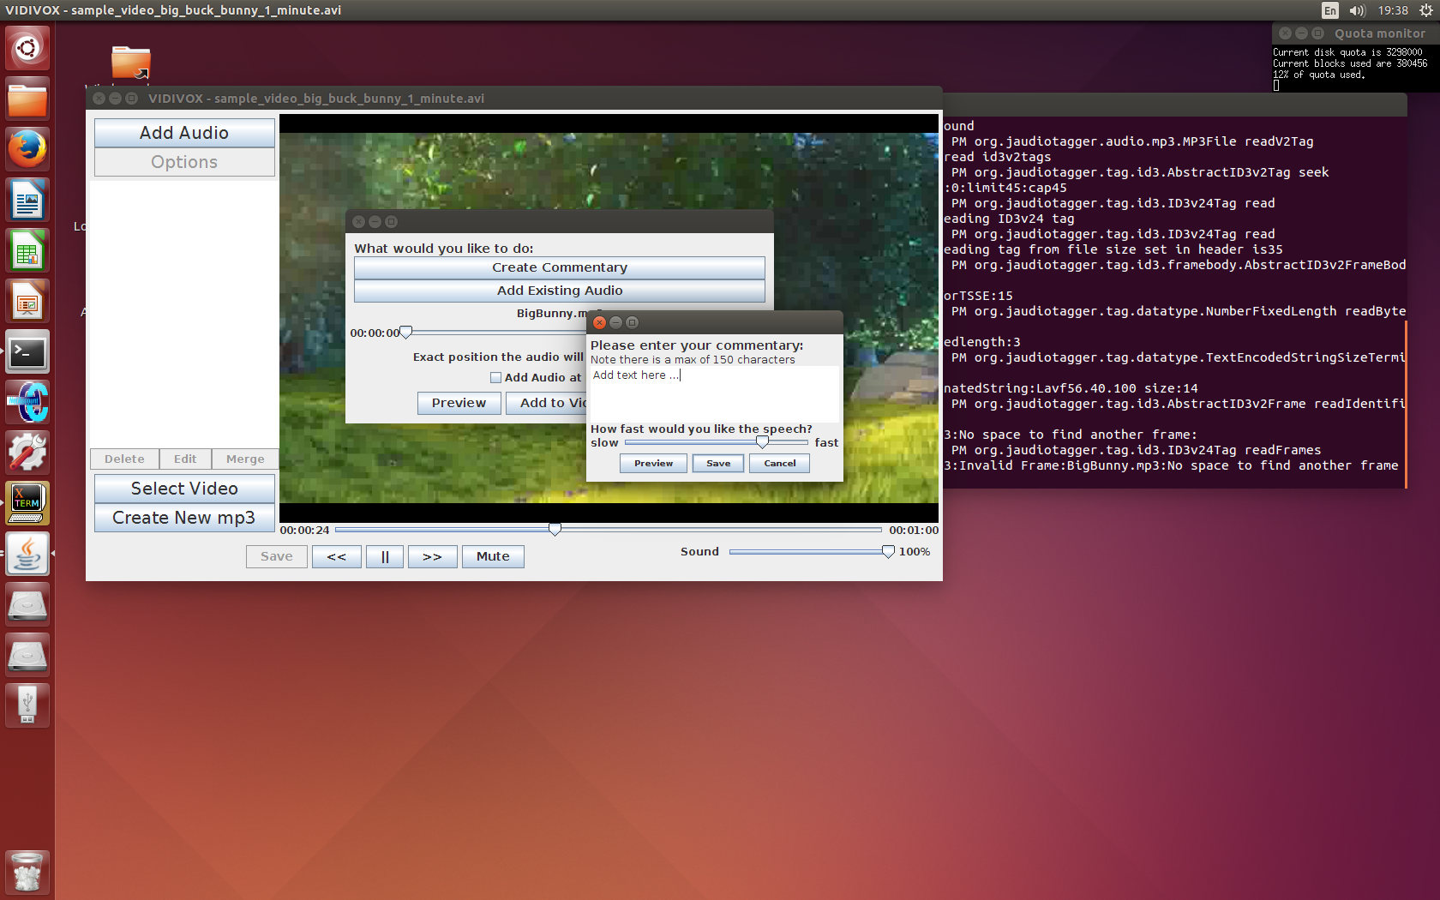The festival functionality that I implemented was to do with how fast festival speaks the text it is given. I wanted the user to be able to control the speed of their speech as this can give each audio quite a different feel. When the user is creating a new commentary, they enter their text and then can use a slider to change and then preview what effect the different speeds have on the text.

In festival to make the speech slower you set Duration_Stretch to a higher value, but when a user looks at a slider like the one above, it is more instinctual for faster speech to have a higher value (to be to the right). Hence I had to take (4 – the slider value) to actually set the stretch, so that the view on the GUI was easier for users to understand and use.

### 3.5.2 Volumes of Individual Audio Files

I also allowed the user to set the volumes of each individual audio file that they add to the video. This was useful as it meant that if there were louder sections of the original video that you still wanted to hear speech over you could simply change the volume for the commentery that you have placed over these sections.

## 3.1 What was the motivation of the selected functionality?

## 3.2 What were the usability decisions?

# 4 Discussion about code design and development of product

## 4.1 Documentation of software design

## 4.2 Development Process

### 4.2.1 Development Process Implemented

### 4.2.2 How this Affected the Project

### 4.2.3 Discussion on Process

## 4.3 Innovative Implementation

## 4.4 Shortcut keys- motivations, implementation

## 4.5 Other developmental issues.

Use of git

# 5 Description of Evaluation and Testing

## 5.1 Evaluation and Testing: Developer

## 5.2 Evaluation from Clients after Pair Project

### 5.2.1 Changes from Assignment 3

### 5.2.2 Justification for decisions

## 5.3 Results of Evaluation and Testing of product by allocated Class Peers

### 5.3.1 Changes from Beta version

### 5.3.2 Justification for decisions

## 5.4 Final Design Testing

### 5.4.1 Error handling

### 5.4.2 Bugs and Fixes

# 6 Future Work

# 7 Conclusions

# 8 User Manual

## Initial Screen

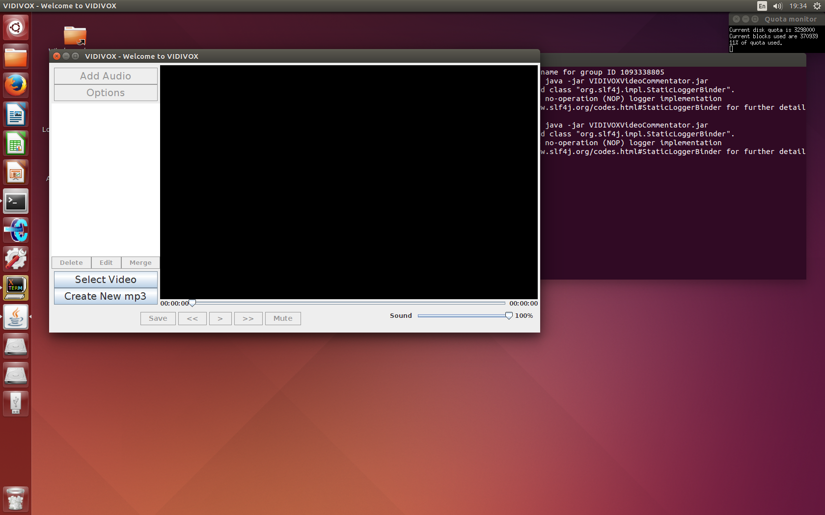

Figure : Image of application on start up

1

2

The first screen you will see looks like *Figure 1*. From the screen you have two options. You can either (1) select a video to edit or (2) create a new commentary file (takes you to (10)).

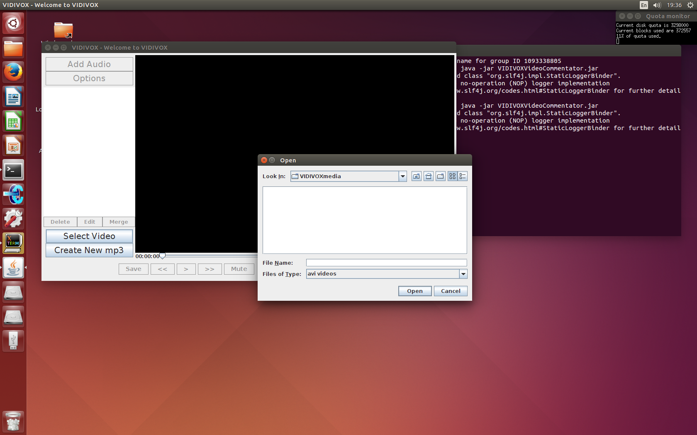All other buttons are greyed out until a video file has been successfully selected, as they are concerned with the playback and editing of the chosen video.

Figure : Default location of the file chooser

## (1) Select Video

When you choose to select a new video, a frame (*Figure 2*) will appear that gives you a way to navigate to the avi file that you want to edit. The default location it will show you is a folder that the app creates when you start it up: “VIDIVOXmedia”. This folder is created in the same directory that the application was saved in. This is the same folder that any files created by the application are saved in (any edited videos, or commentary files).

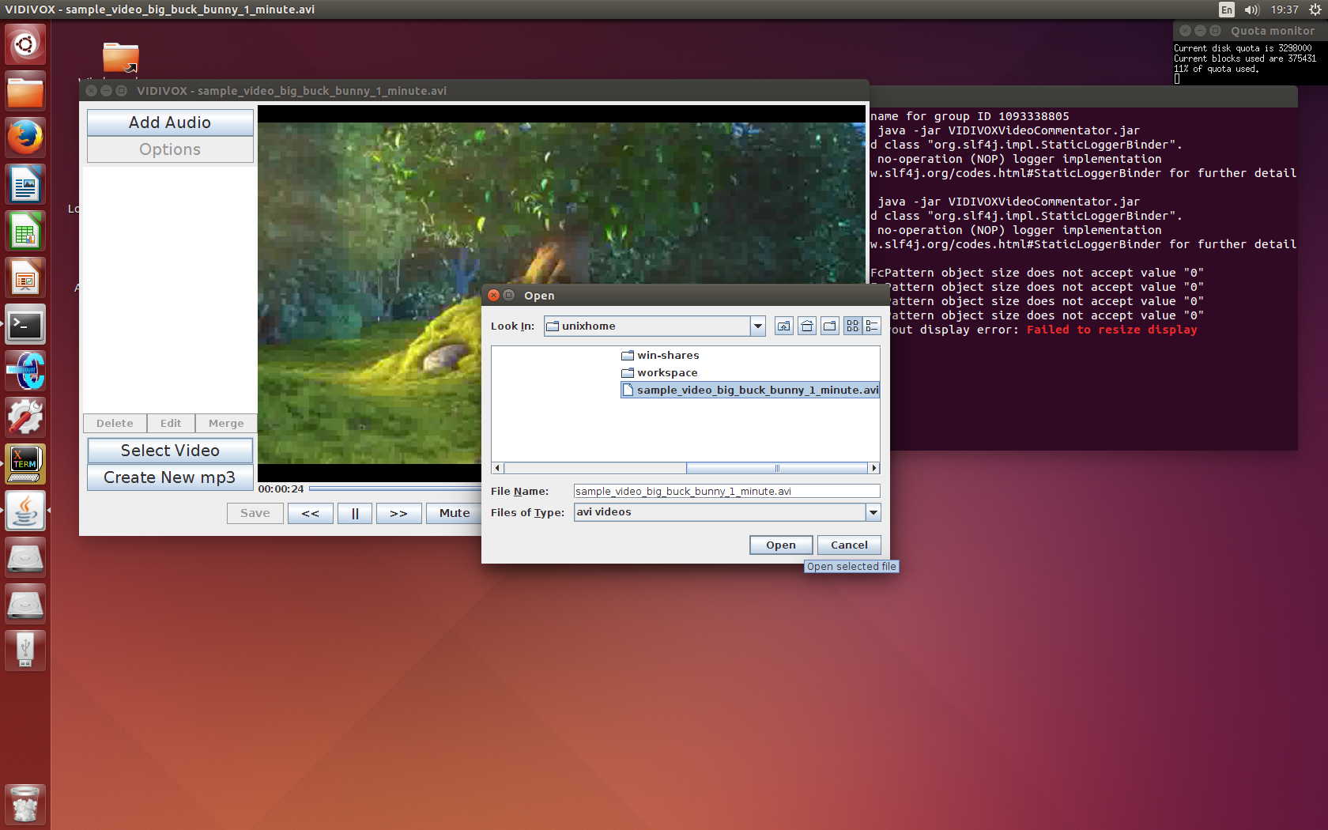

Once you have selected a video, you can choose to open it (*Figure 3*) and once this happens you will see a screen like the one below (*Figure 4*):

Figure : File chooser - file selected

## Video Selected

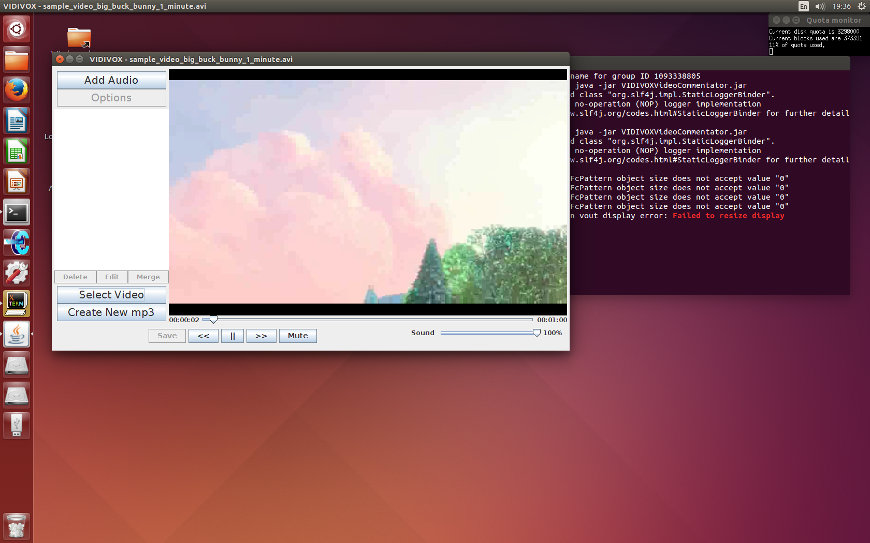

3

4

Now that you have selected a video to edit you can see that a number of the buttons that weren’t enabled before are now enabled. The main video controls (3) can now be used to control playback.

Figure : Video Selected

You can still pick a different video to edit from this frame.

Once you have selected a video you can then choose to add audio files to the video (4).

## (4) Add an audio file to the selected video

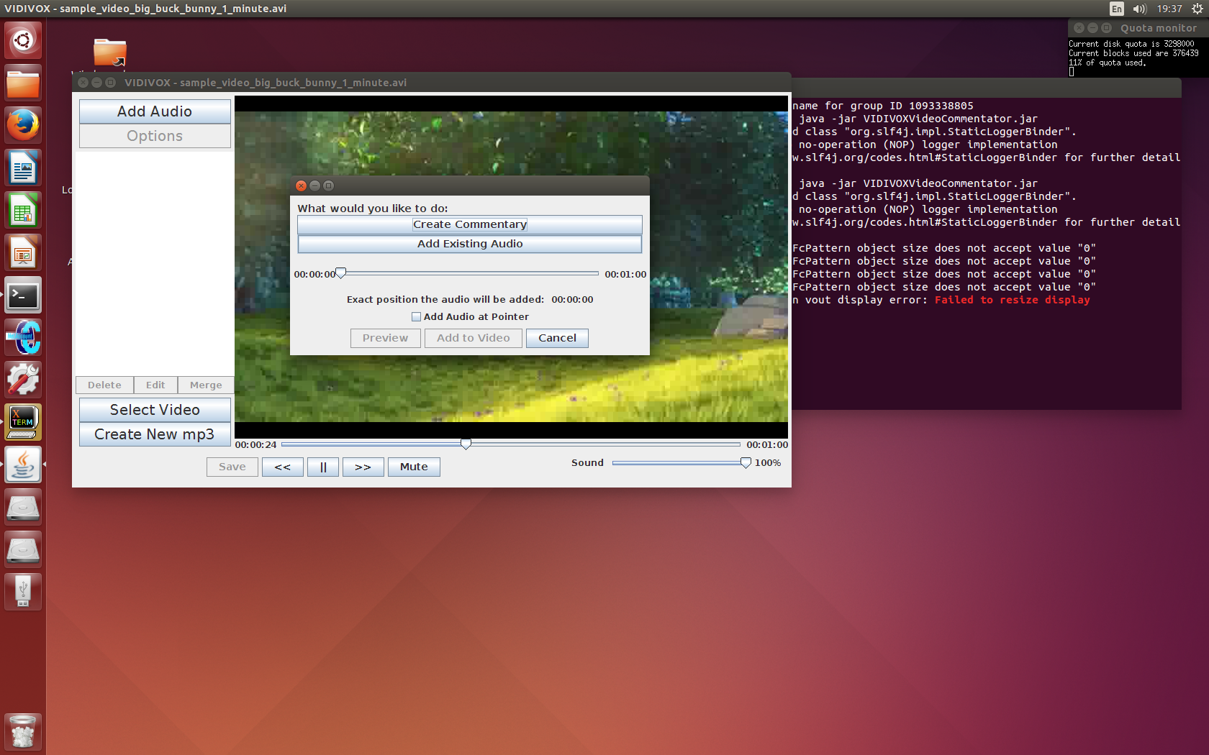

5

6

When you choose to add an audio to the selected video, you see a screen (*Figure 5*) that asks you whether you want to create a new audio file (5) or add an already existing audio file (6).

Figure : Add a new audio file to the selected video file

Note that the slider shows the length of the currently selected video.



7

8

9

10

## (5) Create a new audio file

*Figure 6* let you enter your own text that the application then turns into an audio file. Enter your text into the white area (7), you can use the backspace key to get rid of the text that is already in the field *(“Add text here…”*) or highlight it to remove it all at once. Note that you can only enter a maximum of 150 characters for each audio file in to make sure the computer voice stays audible for the entirety of your text.

Figure : Create a new commentary

The slider (8) lets you change how fast the computer voice speaks when it says your text, and you can test this by pressing the preview button (9). Once you are happy with how your input sounds you can save the audio file by pressing the save button (10).

## (10) Saving an audio file

If you choose to save the audio file that you have created, *Figure 7* will give you a choice to enter a name for your new file. This name cannot contain any punctuation, just alphabet character and numbers. Add the text for your filename to the field (11) and either use backspace to remove the pre-typed name *“MyAudioFile”* or highlight it and delete it to add your own.

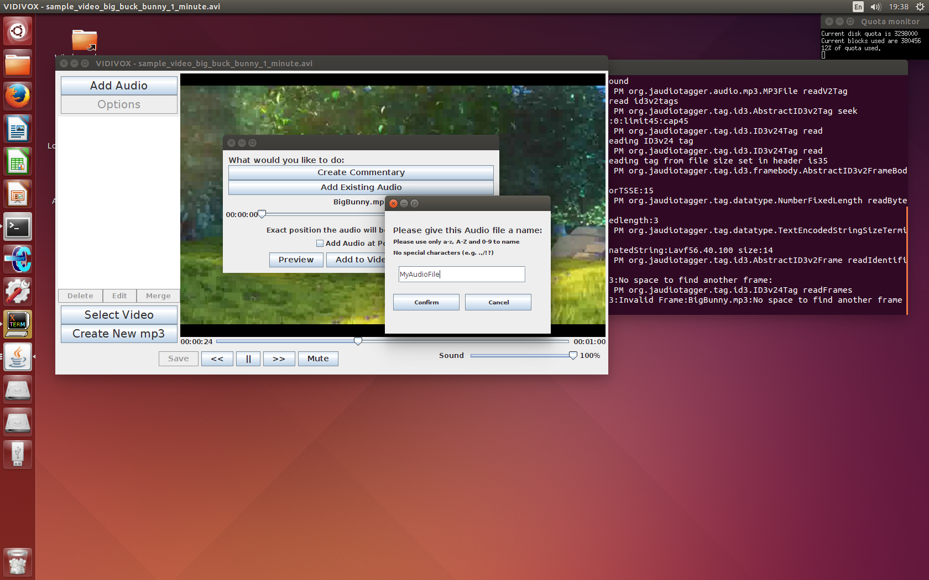

11

12

Figure : Give your new audio file a name

The file will be saved in VIDIVOXmedia, and if you were to choose MyAudioFile as your name, the final audio file would be named MyAudioFile.mp3.

Once you confirm the name you have chosen (12) your chosen audio will be saved (*Figure 8*), and then added to the frame that lets you add audio to the selected video (13).

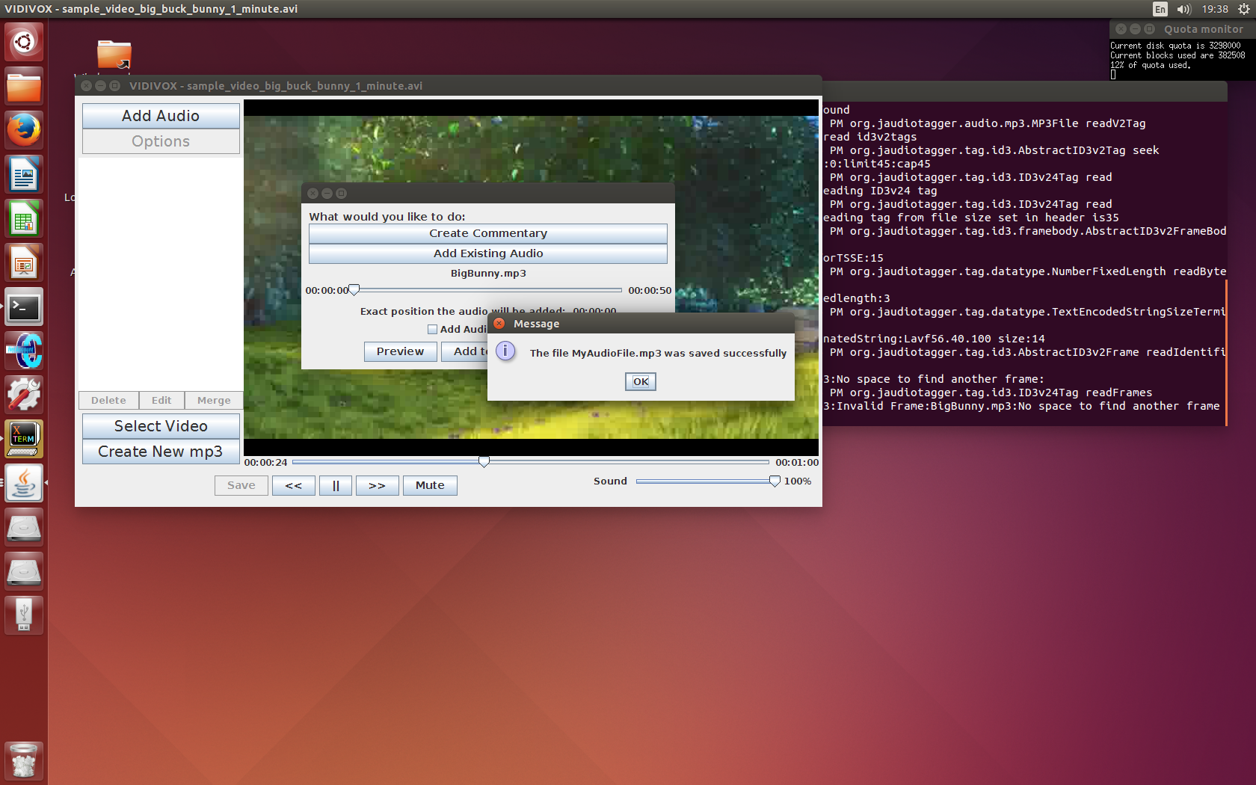Note that if this audio was created without having selected a video to edit first (i.e. you came from (2)), *Figure 8* will be displayed, but the audio name will not be added to the frame that lets you add audio to video (13), it will just return to the initial frame.

Figure : Audio was saved to VIDIVOXmedia succesfully

## (6) Select an existing audio file to add to the selected video

If you choose to add an existing mp3 file, a file chooser (just like the one you used to pick your video) come ups which only shows mp3 files. Again this chooser defaults to the created folder (VIDIVOXmedia) which is where any audio files that you have already created can be found. You can navigate to other part of your file system to find the file you want. Once you are happy select this file and click “open”, and then you will be taken back to the frame that lets you add your selected audio to the video (13).

Figure : Selecting an existing audio - default folder location

## (13) Selected Audio

Once you have selected/created the audio file that you want to add, you will be taken back to the frame that lets you add audio to the selected video (*Figure 5*) but now the name of the audio file you selected/created will have been added to the frame (14). This ensures that you know exactly which audio you are adding.

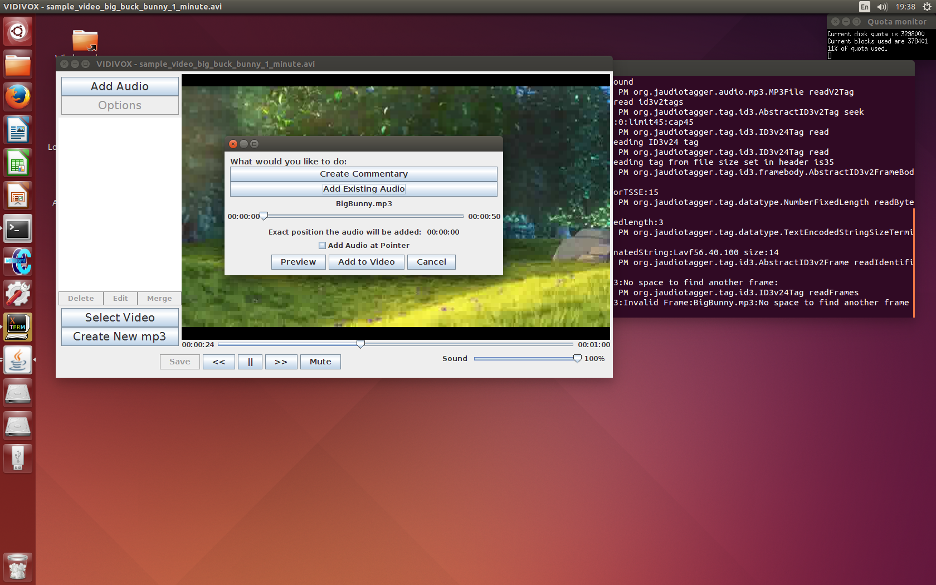

14

15

17

16

Figure : Audio selected to add to video

The “Preview” button (15) and the “Add to Video” button (16) have now been enabled, which means that you can now preview the audio file with the video (just the length of time of the audio) for any given point in the video, and once you are happy with its placing, you can add it to the video.

Notice too that the slider that used to give the length of the video, now gives a different time (17). This time is the length of the video with the length of the audio subtracted from it so that you can’t add an audio that will go over the full length of the audio.

The checkbox “Add Audio at Pointer” can be ticked if you would prefer the audio to be added to the video at exactly the point in time that the video was at when you clicked on the “Add Audio” button on the main frame. If you paused the video in the position that you wanted the audio in before choosing to add an audio file, you will want to check this option (which will grey out the above slider (17)).

To ensure that there is no confusion over the exact time that your chosen audio will be added the time (18) given after the *“Exact position the audio will be added:”* text will always show the time that your video will be added at, regardless of which option you select. For example in *Figure 10* the user has chosen to add the audio at the time selected by the slider shown in the frame, which is currently at the very start of the slider (00:00:00) and the final time reflects this as it also shows (00:00:00).

Once you have finalised your decisions press “Add to Video” to confirm adding this audio to the video (16), and you will be taken back to the initial frame (16 – *Figure 11*).

## (16) Audio file has been added to selected video

As soon as this frame appears the media player will start to play the edited version of the video. You will also notice that a number of other options have become available:

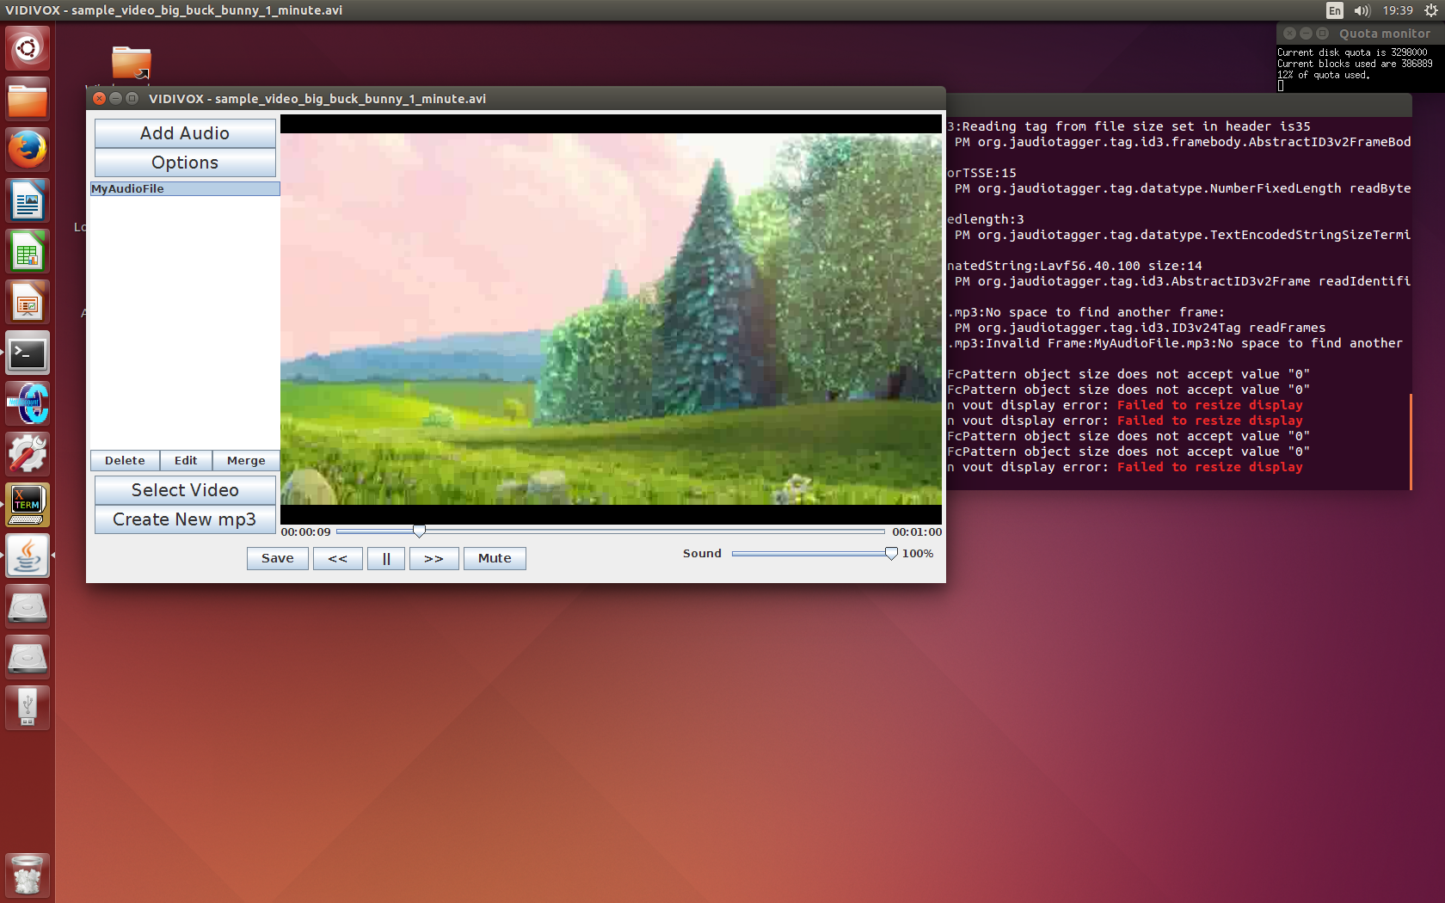

20

21

22

23

24

25

The audio file that you selected to add to the video, has appeared in the list to the left of the video (20), and can now be selected and deleted (21) or edited (22).

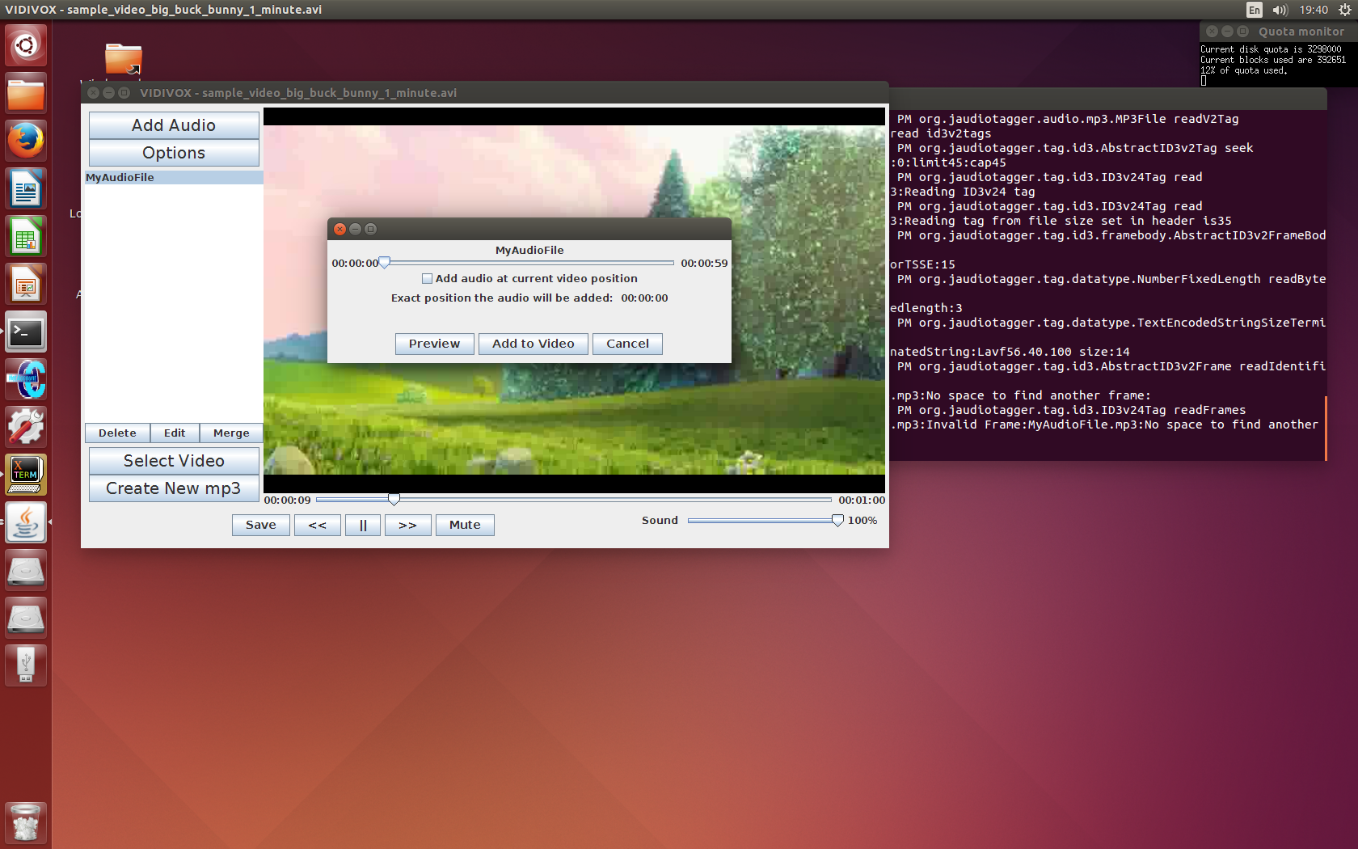If you select an audio to edit (22) this will take you to *Figure 12* which is a variation on the frame that lets you add an audio.

Figure : Audio added to selected video

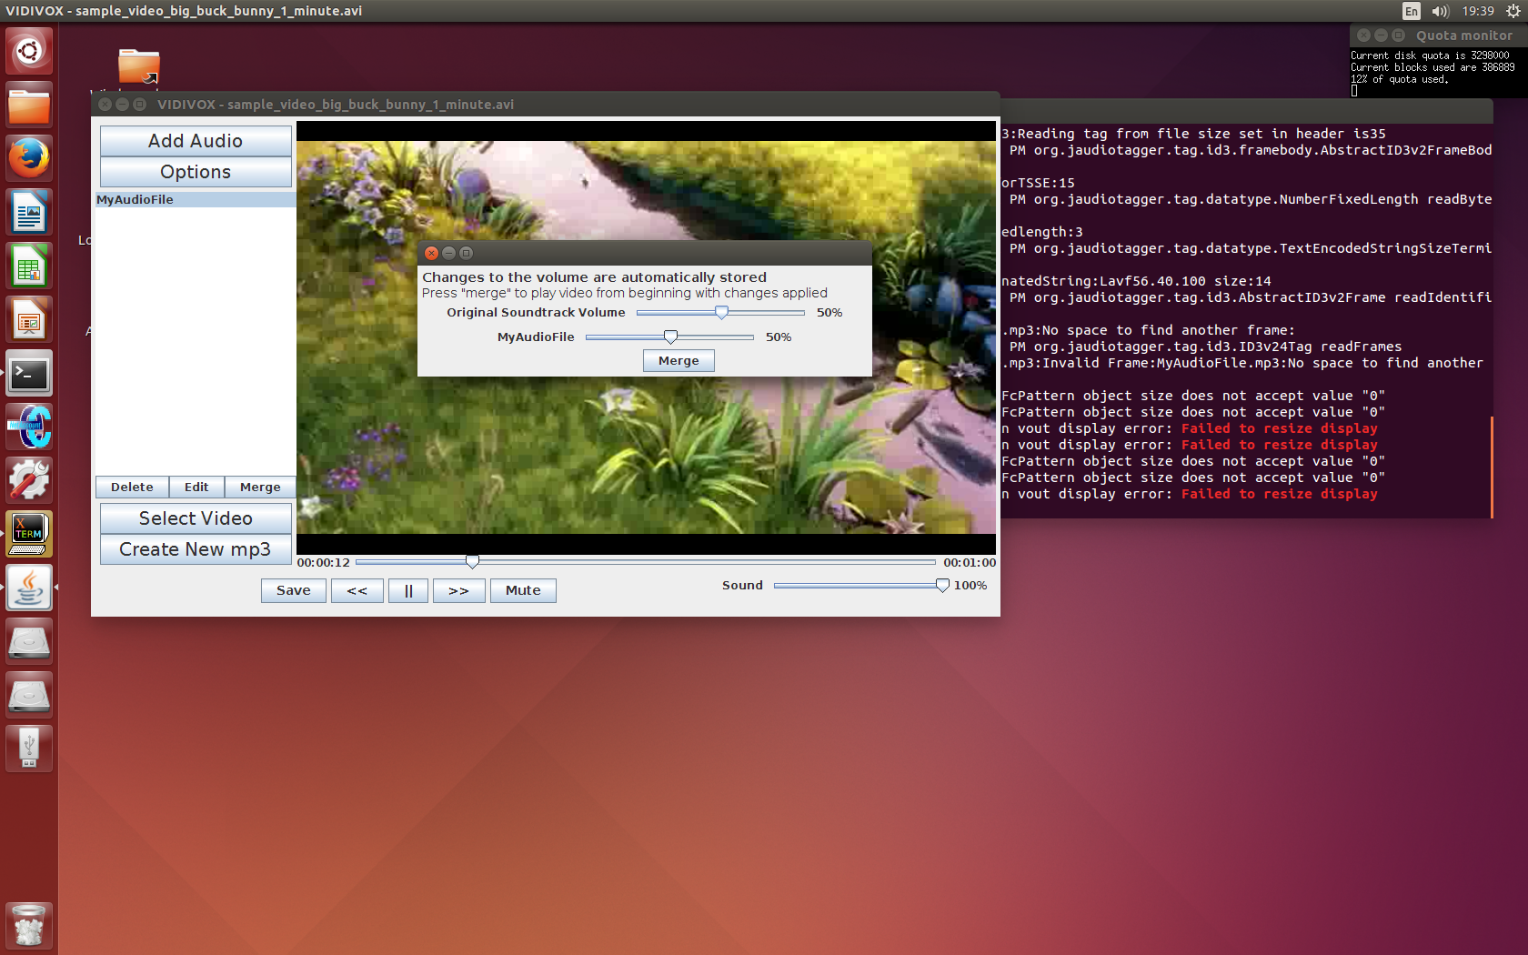The difference is that the edit frame already has the audio set (as this is the one you selected) and you can only alter its position in the video (not what the audio is). As previously, you can still choose to position the audio by using the slider, or by using where you were up to in the video before pressing edit.

Figure : Editing audio that has already been added

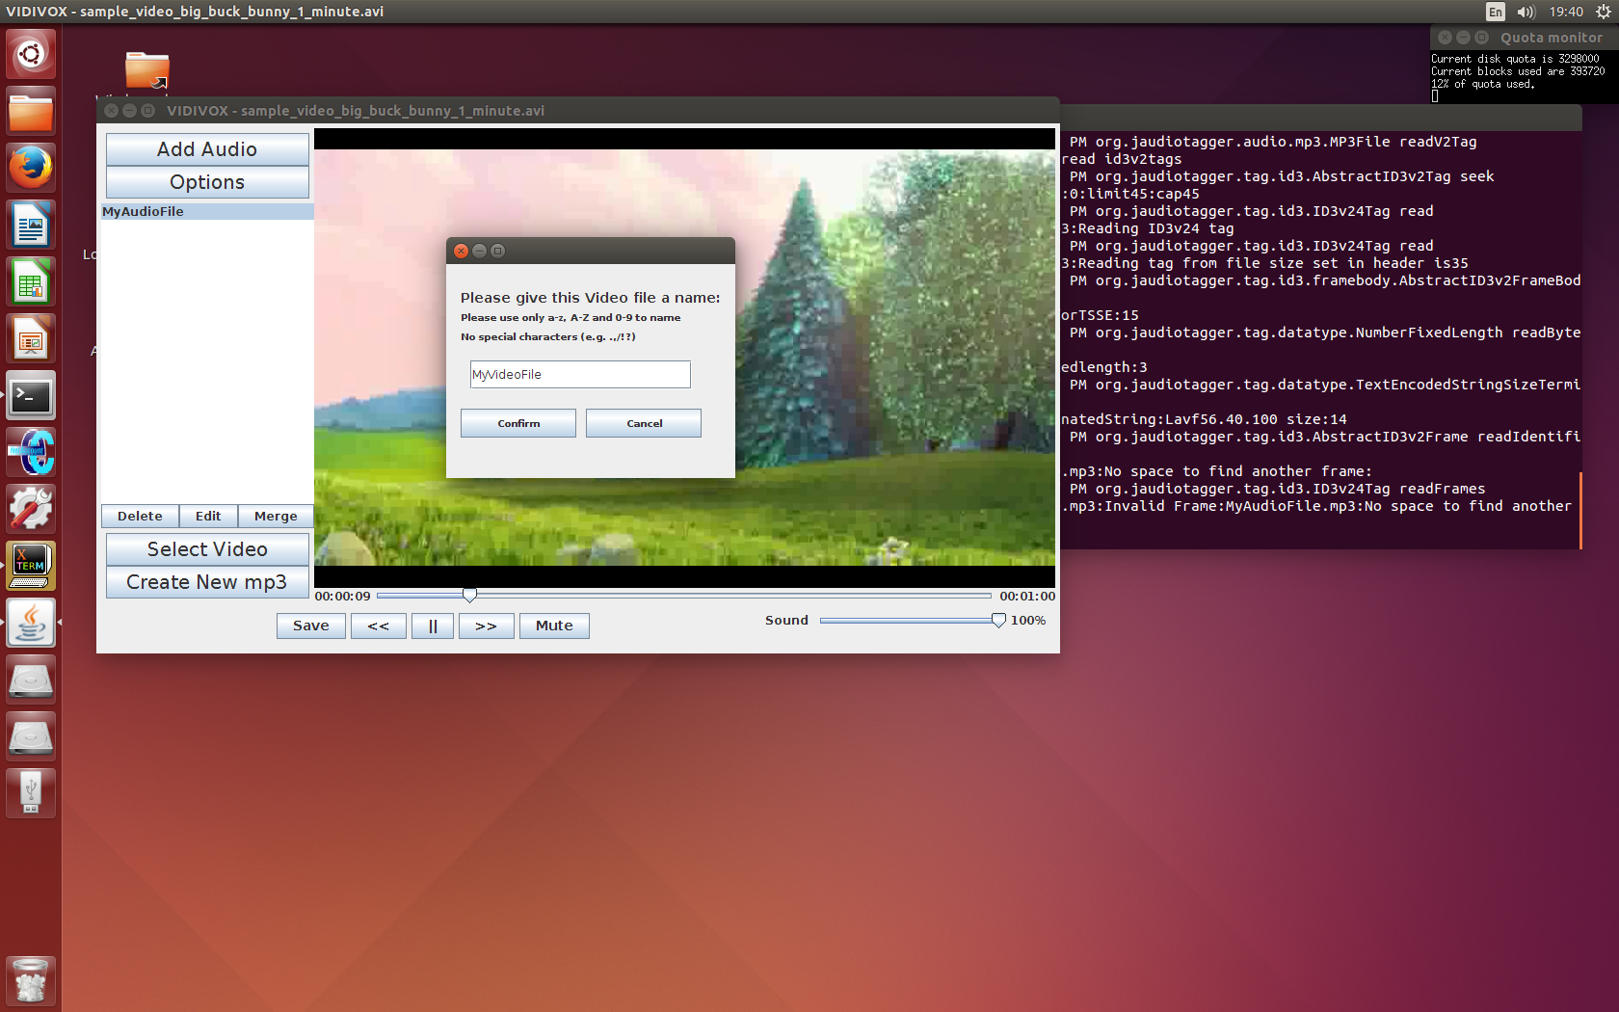Pressing the “Merge” button (23) will cause all the changes made to the audio files to be applied, and the new edited video will be run.

Figure : Options panel - change volumes

The “Options” button (24) has also been enabled, which opens an options pane. Here you can change the volume of each audio in the video. These changes are automatically applied, but the video with all the different volumes will only play once you press the “Merge” button.

## (25) Saving an edited video

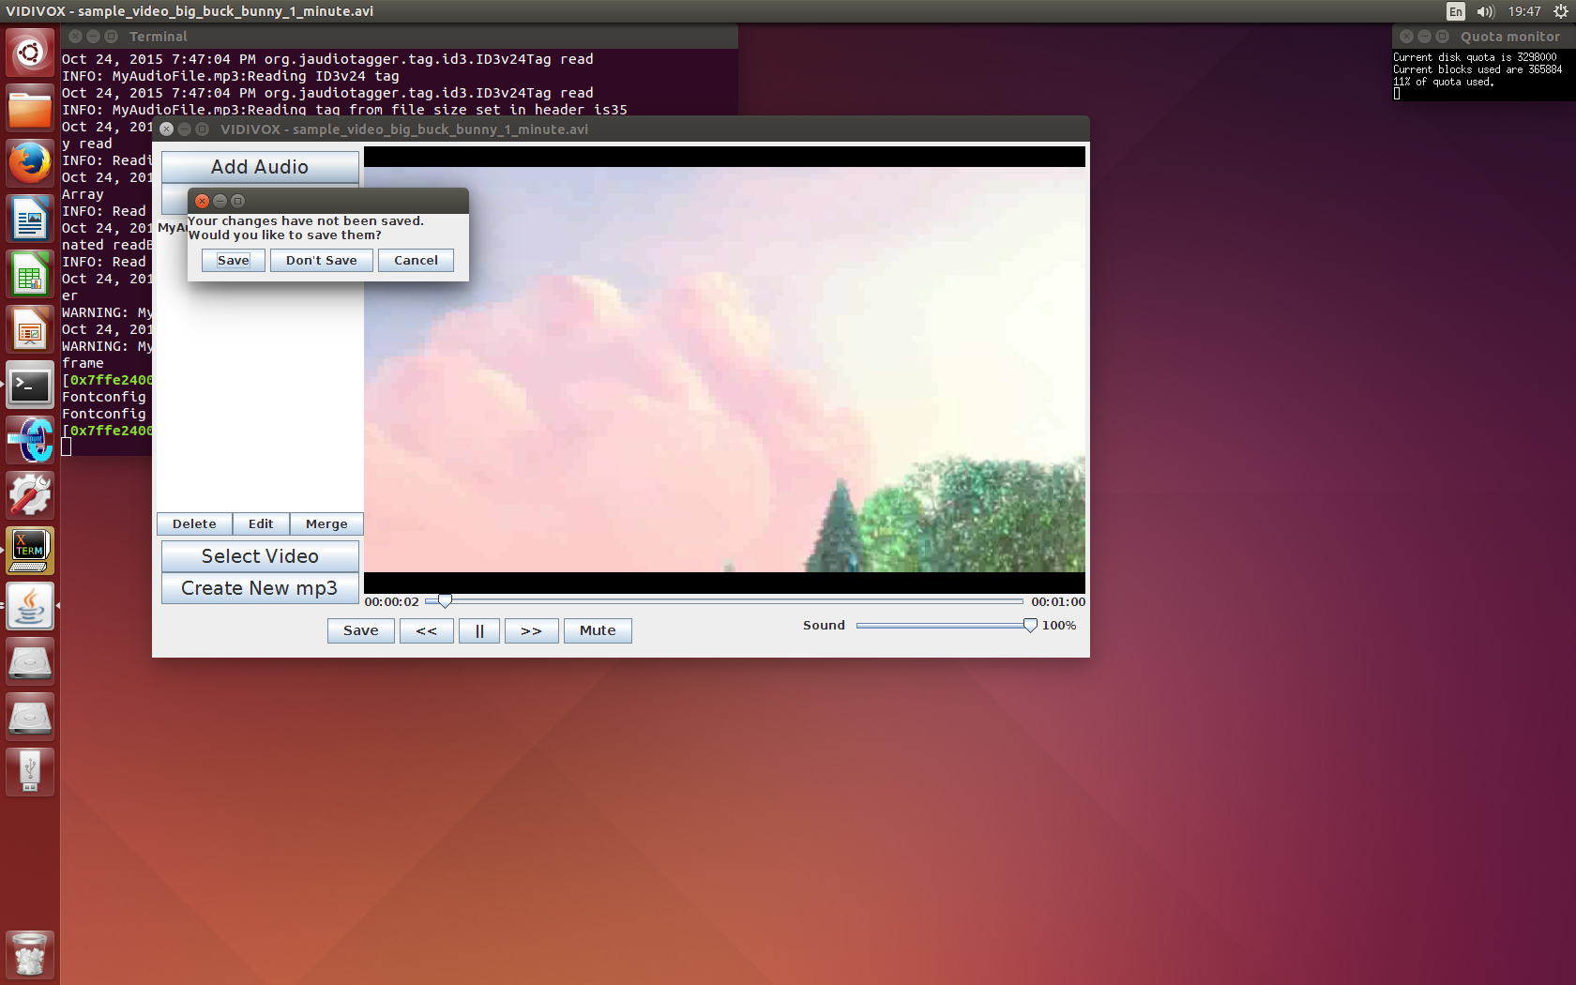Once changes have been made to the video (i.e. an audio file has been added to the video) the save button (25 – *Figure 11*) is enabled, and you are able to save this video, give it a new name (*Figure 14)*, which will then let you know if it was saved successfully.

Figure : Save your edited video with a new name

## Exiting with unsaved changes

If you haven’t saved the most recent changes to your video, and you try to exit a message (*Figure 15*) will come up prompting you to save these changes, exit without saving, or to cancel the exit.

Figure : Message that occurs when exiting with unsaved changes

Please note that deleting any video or audio files while you are working on them or editing them will cause the video editor to stop working properly. If this occurs you will need to reload your files.